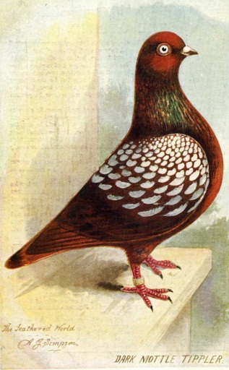 | The  United Show Tippler  Club  Formed 1891  Affiliated to the NPA  Membership Application Form

Name :
Address :

Post Code :

Telephone No :

e-Mail Address :

Website Address :

Where did you obtain your birds from?

Do you show your birds? YES / NO
Membership Fee enclosed:

Single : £5 p.a. Joint : £7.50 p.a.

(Cheques made payable to John S Harrison)

I /We wish to apply for membership of The United Show Tippler Club. I/we agree to abide by the rules of the Society. In accordance with the Data Protection Act 1984, I hereby give permission for information given on this form to be held on a computer record.

Signature of applicant(s):

Date:

Completed form with fees to be returned
to the Secretary:
John S Harrison
Garnedd Ucha, Dolwen, Nr Abergele, North Wales, LL22 8PA

